Steps to enter service PRO and update the tickets assigned

1. Copy below URL and open in Internet Explorer.
   * <http://helpstar.rlcarriers.com/ServicePRO>
2. Click on **My Views**

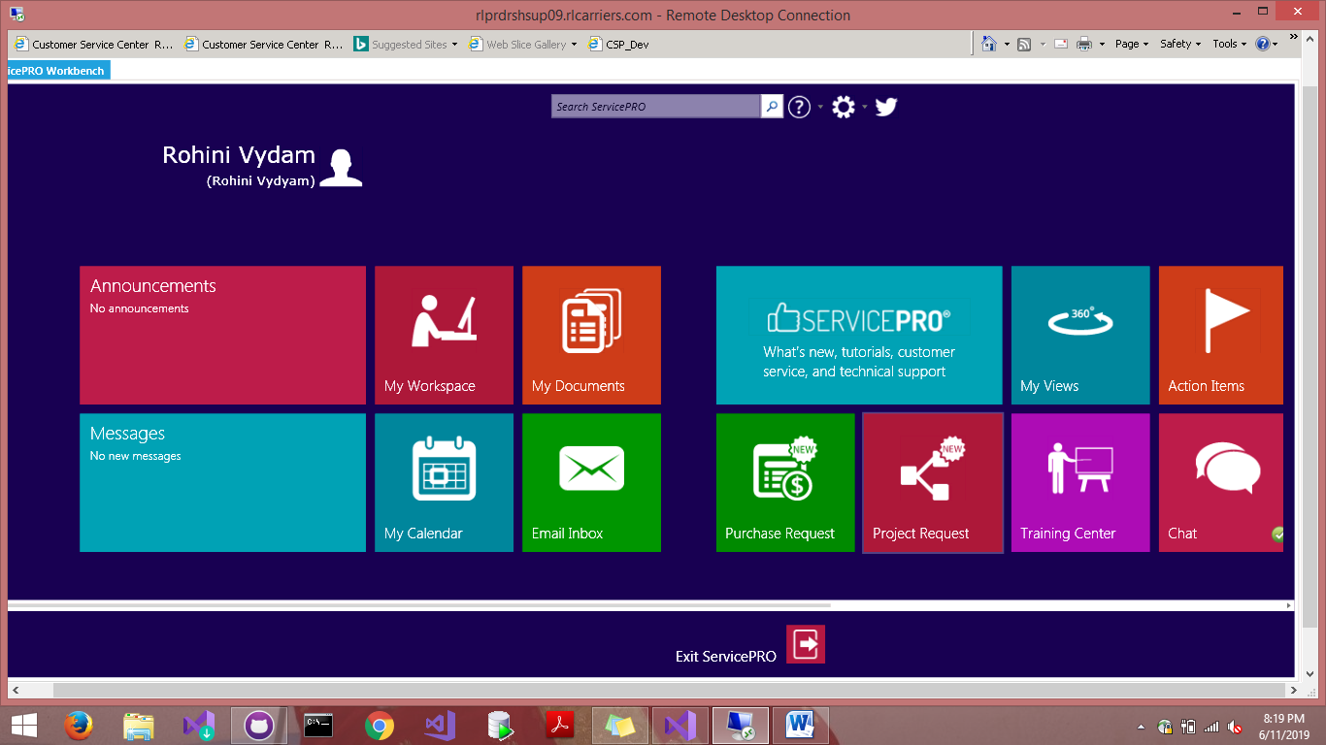

1. Click on **All WorkSpaces**

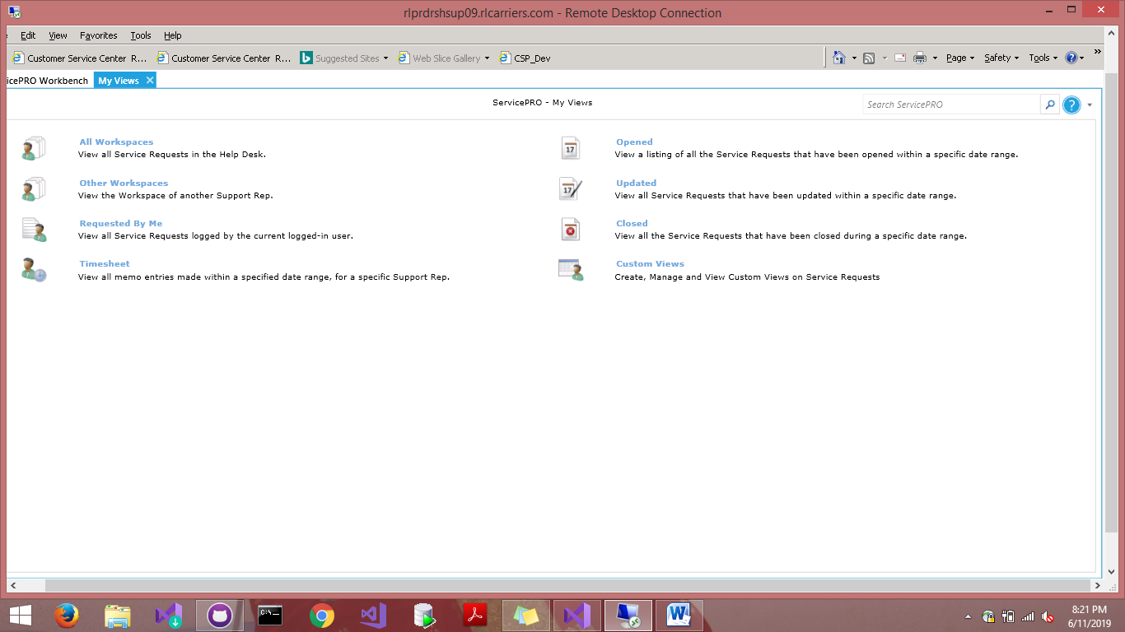

1. We handle the tickets that come under
   * EnterpriseApplicationDevelopment 🡪 Normal Break Fix
     1. CRM
     2. Ops Dashboard
     3. Support Team
     4. Trip Planner which are colored in red below.

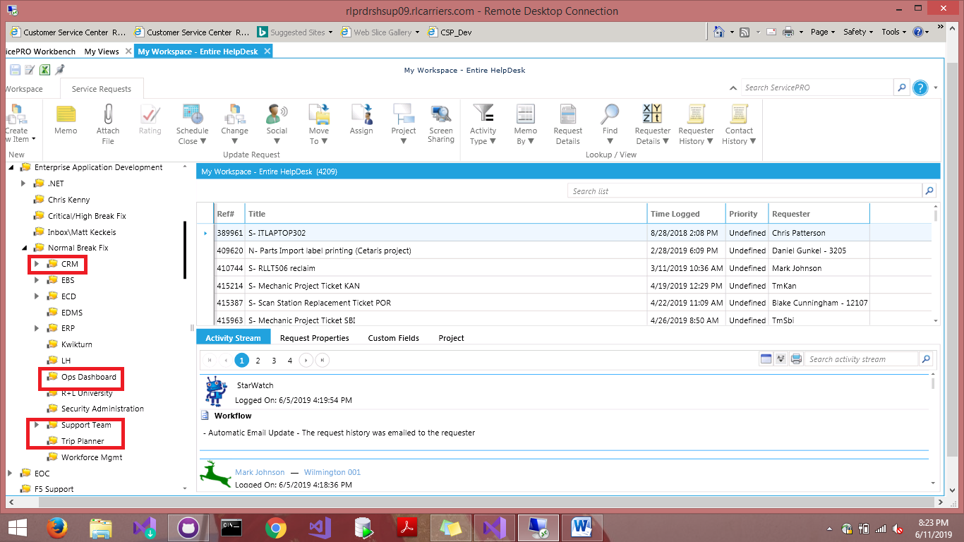

1. Item created on TFS(**Dashboard**)

**Screenshot: 1**

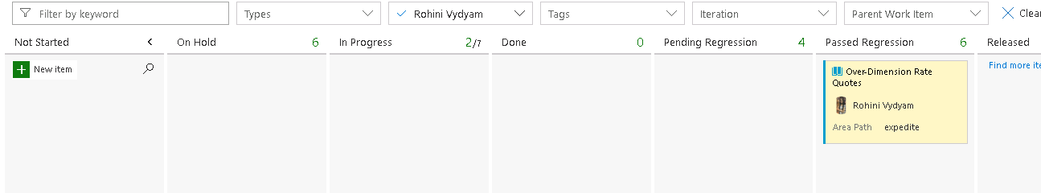

1. Create one support ticket dump excel and Copy all the tickets that are under the folders mentioned above in the below format

|  |  |
| --- | --- |
| Date | The date we got ticket in our bucket |
| Date Assigned | The date we are assigned that ticket |
| User story | Make it as bug |
| HS# | Ticket number |
| Title | Ticket title |
| Folder | In which folder we got the ticket |
| Moved to TFS | For every ticket we will create an item on dashboard (Screenshot 1 above) |
| Assigned To | Name of the person to whom the ticket is assigned |
| ROM | How many hours of today is spent on that ticket |
| Category | |  |  | | --- | --- | | **Break Fix:** | If there is any code fix that comes under break fix | | **Investigation:** | Without any changes in code if the resolution is given. | | **Enhancement:** | Enhancing the existing functionality. | |
| HS Status | |  |  | | --- | --- | | **In Queue:** | If the ticket resolution is in progress we will keep it in queue | | **Dispatch:** | If we need any inputs from user or the issue is fixed. | | **Closed:** | If the ticket status is closed in TFS | |
| TFS Status | |  |  | | --- | --- | | **Not Started:** | If the team has not picked up the ticket but is still in queue | | **On Hold:** | Awaiting inputs from user/Onsite/dependency | | **In progress:** | When team starts working on ticket | | **Done:** | This is mostly applicable to enhancement tickets when development done and awaiting staging. | | **Pending Regression:** | QA is testing on staging | | **Passed Regression:** | Testing done and QA signed off staging | | **Released:** | Issue is fixed from our end | |
| Status | |  |  | | --- | --- | | **WIP:** | If the team is working on the ticket. | | **Impediment:** | If the ticket is On Hold | | **Completed:** | If the ticket is fixed from your end. | |
| Closed | Date on which tickets moved to released status on Dashboard / tickets closed in help star. |
| WE | Carry forward tickets also contain the weekend date of current week. |
| WK# | Id of the week as per the sheet |
| Month | Current month |
| Comments | Update for open/pending tickets |

1. Ticket assignment will be done by team lead; we will be assigned the tickets and below is the way to search the details of the ticket. (Ex: 417926 )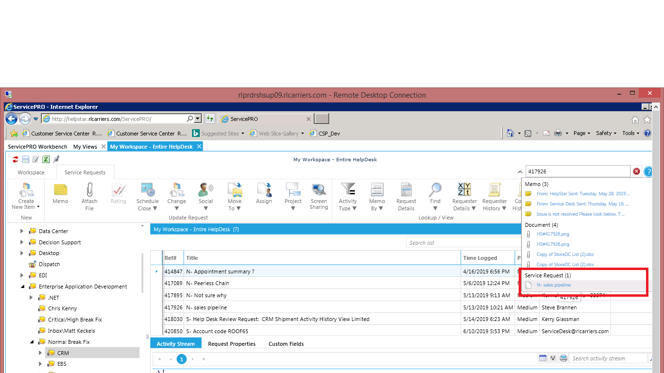
2. Click on the below highlighted part and update the ticket as shown in below steps:

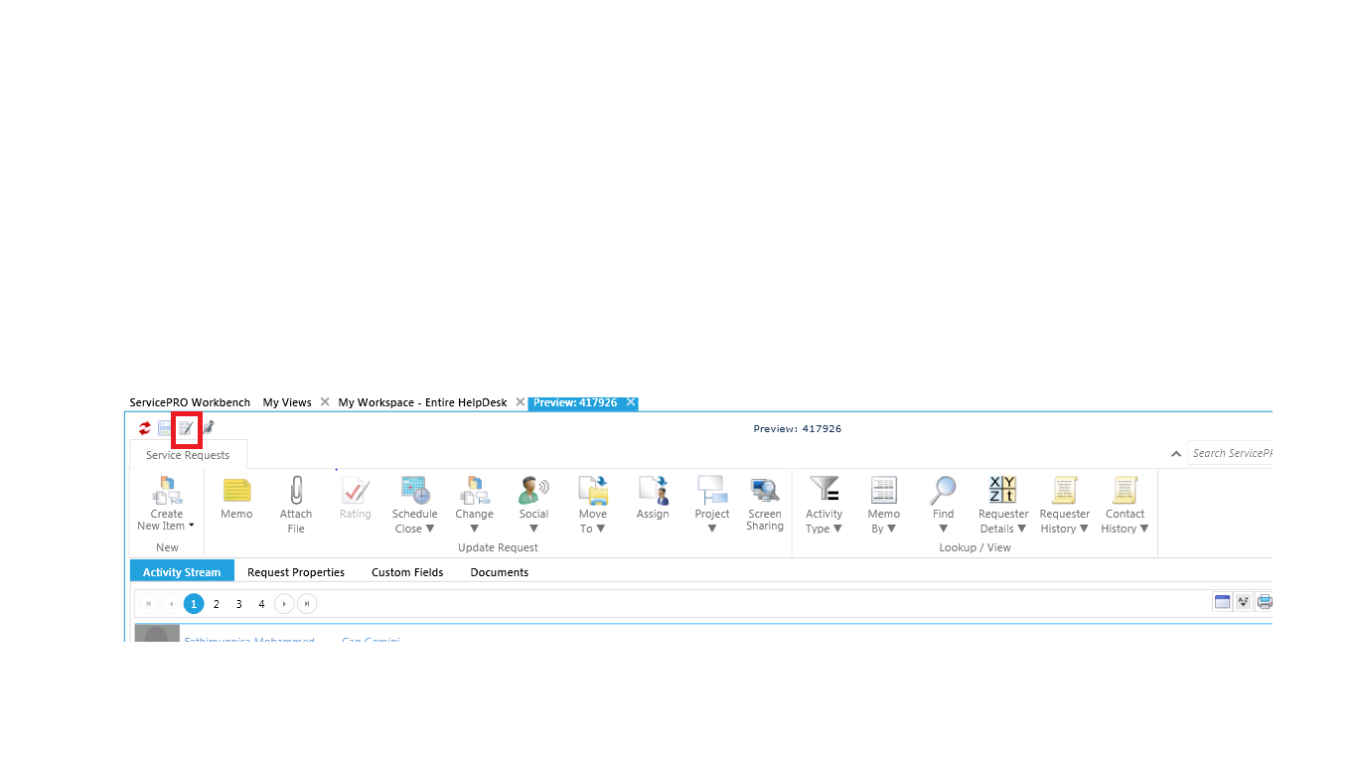

1. Set the category as Support 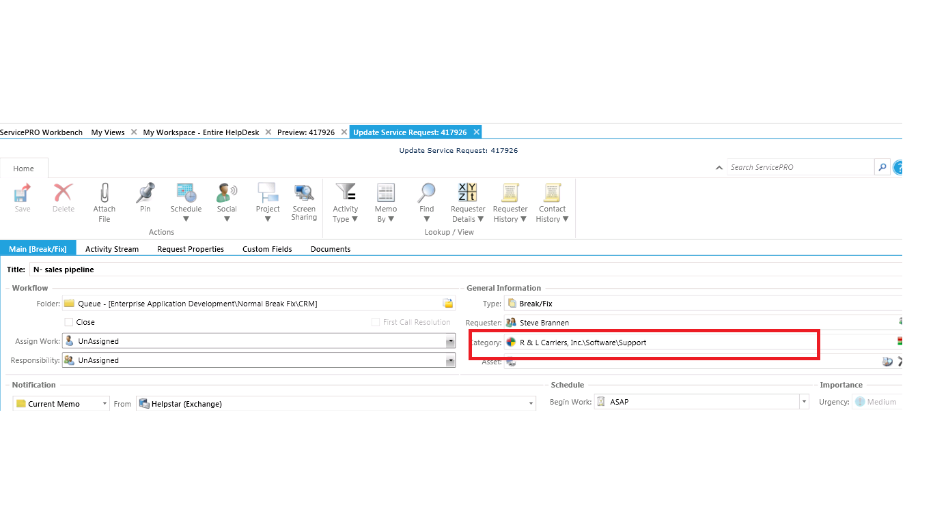
2. Type support and click on ok then the type will be selected as support

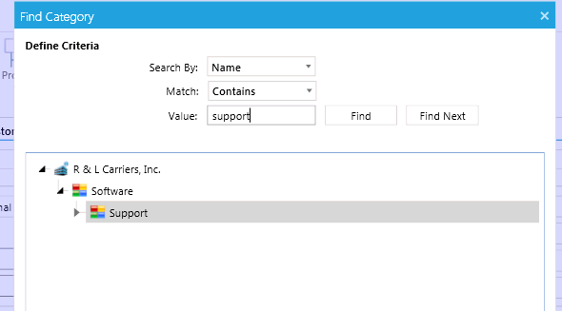

1. Go to Custom fields tab 🡪 Dev Stage 🡪 And type the application name in Assigned to textbox(max 4 letters allowed)

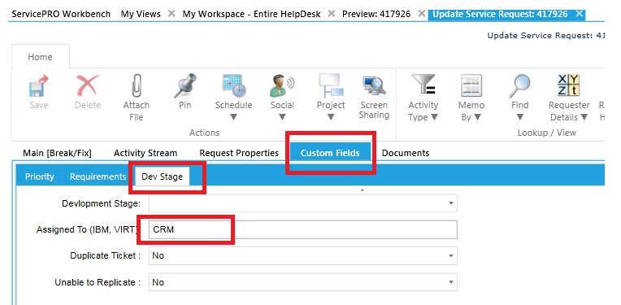

1. Enter the ticket resolution and click on save as shown below.

